Software Requirements Specification

for ATM OPERATIONAL SOFTWARE
Version 1.0 approved
Prepared by < yaroub ali- jamil mhamad- issa alkhder-eyad mando>
Al Baath University
6TH JUNE 2020
Table of Contents
Table of Contents ii
Preface ii
1. Introduction 1
1.1 Purpose 1
1.2 Project Scope 1
1.3 Glossary 1
1.4 Intended Audience and Reading Suggestions 1
1.5 References 1
2. Overall Description 2
2.1 system environment 2
2.2 Product Functions 2
2.3 User Classes and Characteristics 2
2.4 Scenarios 2
2.5 Use Case Model Survey 2
2.6 Operating Environment 2
2.7 User Documentation 2
3. External Interface Requirements 3
4.1 User Interfaces 3
4.2 Software Interfaces 3
4.3 Communications Interfaces 3
4. Functional requirements ..................................................................................................4
4.1 Authentication………………………………………………………………………………4
4.2 Banking transactions……………………………………………………………………...4
5. Other Nonfunctional Requirements 5
5.1 Performance Requirements 5
5.2 Safety Requirements 5
5.3 Security Requirements 5

Introduction

Purpose

This Software Requirements Specification (SRS) is intended for users and managers of the ATM OPERATIONAL SOFTWARE and those evaluating its potential use.

Project Scope

The software supports a computerized banking system. The system enables customers to complete simple bank account service via an ATM. An ATM session consists of authenticating a user (i.e., proving the user's identity) based on an account number and personal identification number (PIN), followed by creating and executing financial transactions. To authenticate a user and perform transactions, the ATM must interact with the bank's account information database. For each bank account, the database stores an account number, a PIN and a balance indicating the amount of money in the account. ATM users should be able to view their account balance, withdraw cash (i.e., take money out of an account) and deposit funds (i.e., place money into an account).

1.3 Glossary

- Account

A single account in a bank against which transactions can be applied. Accounts maybe of various types with at least checking and savings. A customer can hold more than one account.

- ATM
An electronic telecommunications device that enables the customers of a financial institution to perform financial transactions without the need for a human cashier, clerk or bank teller.
- Bank

A financial institution that holds accounts for customers and that issues account numbers and passwords authorizing access to accounts over the ATM network

- Bank computer

The computer owned by a bank that interfaces with the ATM network and the banks own cashier stations. A bank may actually have its own internal network of computers to process accounts but we are only concerned with the one that interacts with the network.

- Customer

The holder of one or more accounts in a bank. A customer can consist of one or more

Persons or corporations the correspondence is not relevant to this problem. The same person holding an account at a different bank is considered a different customer.

- Database

A database is an organized collection of data stored on a computer

1.4 Intended Audience and Reading Suggestions
The intended audience for this SRS consists of:

• Software engineers

• System engineers

• System customers

• System test engineers

1.5 References

- Software engineering / Ian Sommerville. — 9th ed.

Overall Description

2.1 system environment

BANKING
SYSTEM


DATABASE

COMPUTER/ATM
This ATM’s software is to run on a new ATM hardware that a local bank wants to install for its customers. The system will be designed in such a way that the user will access and use the ATM and then accesses the banking system, which updates, configures and accesses the details and data of the user from his/her database. The system will also accommodate an operator who will load money in the ATM machine, validate deposits made by a customer, and make sure the system hardware is always on and on power.

2.2 Product Functions

The functions of the system are:
- Login
- Balance inquiry

- Cash withdraw

- Funds deposit

2.3 User Classes and Characteristics

- Open to all users but access level is dependent on knowledge of the system.

- Customers are simply members of the public with no special training.
- Bank security personnel need have no special education or experience.

- Maintainers must be experienced system administrators, able to upgrade and repair the system.

2.4 Scenarios

2.4.1 Initial assumption

The assumption made are:
- An individual with a valid bank account and valid unique PIN attempts to access the banking system services using the ATM.

- The ATM machine has money loaded that will be able to be withdrawn by a customer

- The customer knows how to use the ATM machine.

- The ATM is always on.

2.4.2 Normal

For the user:

- The customer enters the account number and pin and is successfully validated by the banking system

- The customer is logged in the system and is able to withdraw cash after entering the pin and account number

- The customer is logged in the system and is able to Deposit cash after entering her pin and account number

- The customer can request a query balance of his/her account

For the operator:

- The operator can successfully update the customer’s account and database after a deposit transaction of a customer

- He/she is able to keep the ATM on power all the time

- He/she is able to load cash in the ATM machine, which customers will be able to withdraw

2.4.3 What can go wrong

- Unauthorized access for an account by a user who is not the owner of that particular account

- Failure to update the bank account database after a customer makes a transaction

- Operator making an accounting error and updating a customer’s account wrongly after a customer deposits cash

- A customer trying to withdraw cash that is greater than that is in the customer’s account

2.5 Use Case Model Survey

This subsection includes actors and use cases that are present.

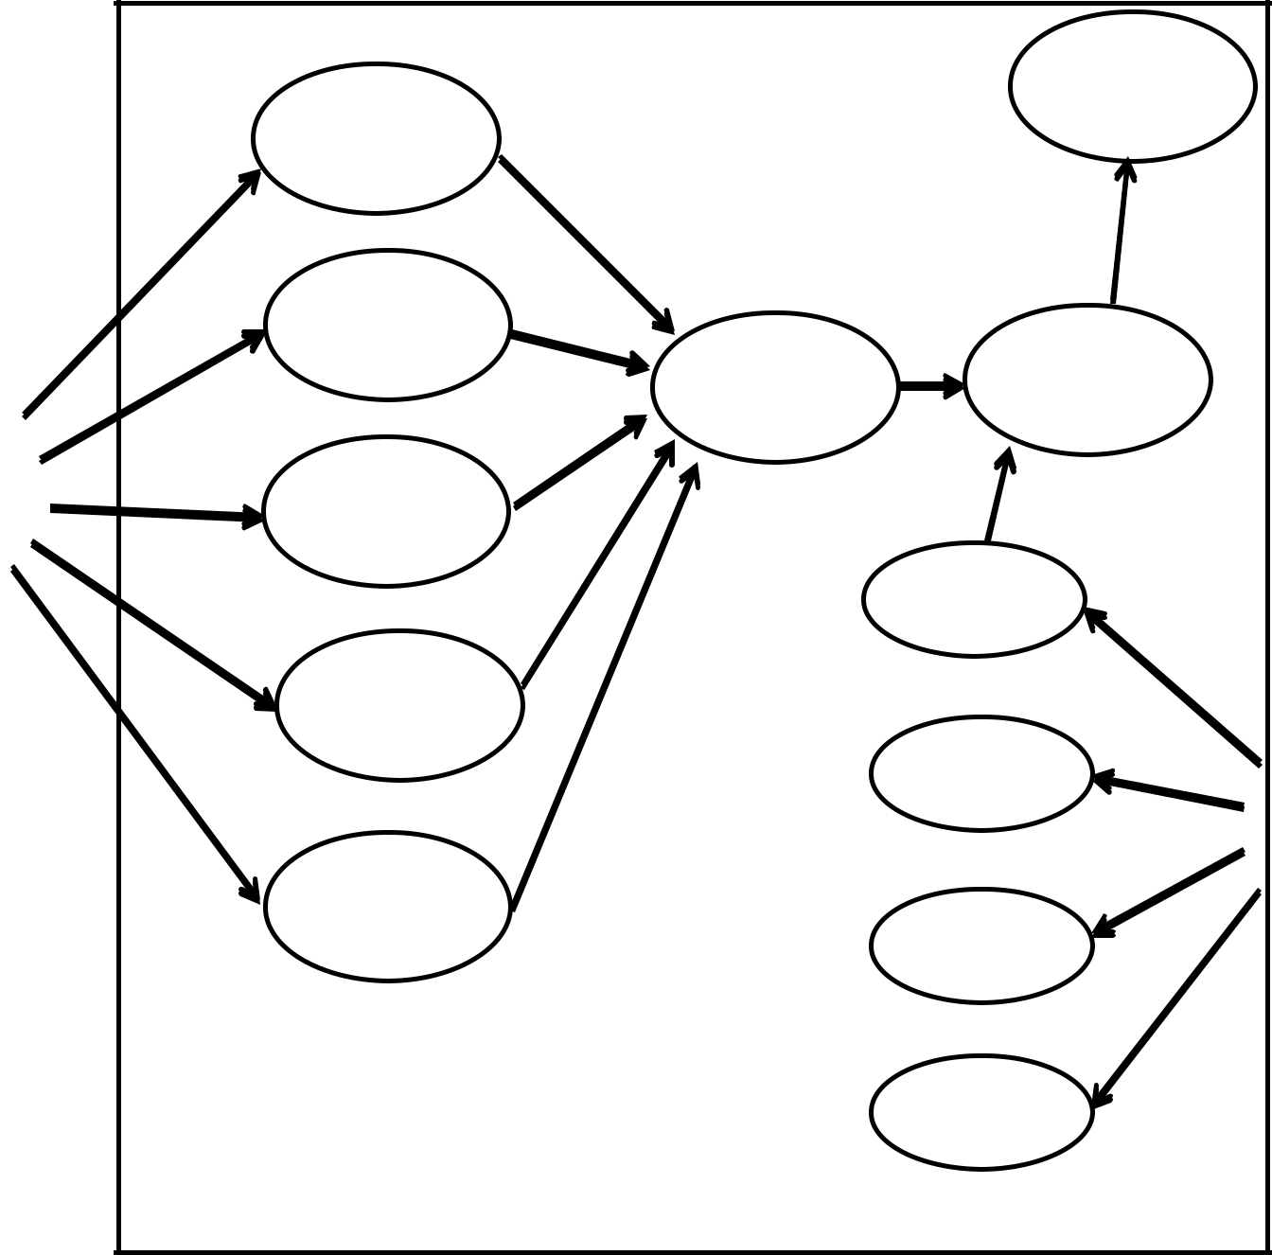

ENTER DATABASE
A/C NO..AND
PIN

BALANCE
ENQUIRY BANKING
VALIDATE SYSTEM

WITH
DRAW MONEY

USER COUNT

DEPOSIT
MONEY
ADD
CASH

EXIT
STARTUP
OPERATOR

SHUT DOWN

